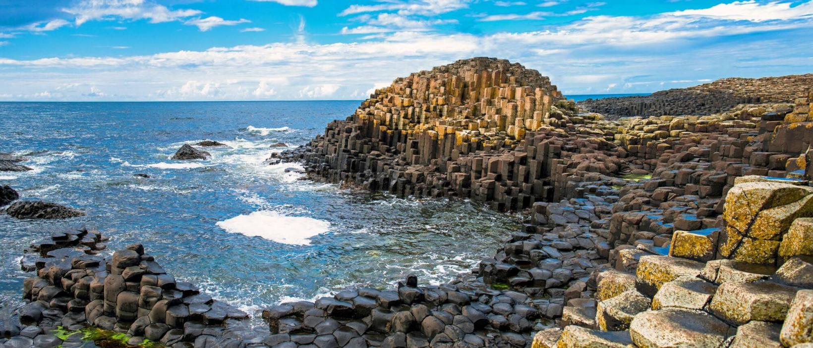



2026 British Isles
Adventure Handbook
WELCOME TO THE BRITISH ISLES

Céad Míle Fáilte!

Welcome to your Adventures by Disney British Isles vacation. Soon, you will experience the warm, welcoming people of Dublin, to the seaside beauty and storied past of Belfast, to the cobblestone streets and ancient castles of Edinburgh, and to London, a modern city steeped in history. The﻿ archipelago known as the British Isles offers something for everyone!﻿ Consider this a helpful travel companion containing general travel tips and daily itineraries.

Just like all real adventures, it is subject to change. However, you can rest assured that we will advise you of any changes or new developments if and when they occur.

During your adventure, tag your photos with #ABDinBritishIsles﻿ for an opportunity to be featured on Adventures by Disney's social media handles!

Thank you for making memories with us!

Cheers!

BEFORE YOU GO

REQUIRED DOCUMENTATION
International:
For all trips outside the United States, you are required to carry a passport in order to travel in and out of the country. The following are guidelines for international travel. You will need a valid passport to enter the country and to return to the United States.
- It must be valid six months beyond your intended stay and have 2 blank pages remaining.
- Allow yourself sufficient time to have your application processed if you are applying for a new passport or renewing an expired passport.
Please consult the U.S. Department of State website at travel.state.gov for further details.
Electronic Travel Authorization (ETA)
In addition to a valid passport, non-European Guests may be required to obtain multiple-entry visas, or travel authorizations from the list below:
- United Kingdom or United Kingdom Electronic Travel Authorization (ETA) based on your nationality.
Please note, it is the Guest's responsibility to identify and obtain all necessary visas before commencing their trip.
There is an added cost for an ETA, which permits multiple journeys to the United Kingdom for stays of up to six months at a time over two years, or until the holder’s passport expires – whichever is sooner.
If you have any questions about this requirement, Adventures by Disney Vacationistas are available at (877) 728-7282 Monday-Friday 8:00 AM – 10:00 PM EST.
Non-U.S. Citizens
Non-U.S. citizens and alien residents of the United States, please refer to the UK Embassy and Irish Department of Foreign Affairs websites for your country of origin.

TRAVEL INFORMATION

Use these checklists to help ensure your Adventures by Disney vacation is hassle-free.

Provide Your Information
Prior to your Adventures by Disney vacation, be sure to provide a Vacationista with the following information:

- Flight information
- Passport information
- Special room requests
- Special dietary requests
- Special activity-related requests

Contact a Vacationista
Adventures by Disney Vacationistas are available at (877) 728-7282 during the following business hours:
Monday – Friday from 9:00am – 8:00pm ET

Prior to Your Departure
Leading up to your vacation:

- Contact your banking institution and credit card companies to notify them that you will be traveling
- Contact your wireless provider for rates and charges when traveling

Before leaving for the airport:
- Pack carry-on luggage with necessary travel documentation (passport and government issued ID)
- Pack any medical necessities

What to pack

Luggage
While each airline has different restrictions for baggage allowances, general guidelines allow for each Guest to bring one checked bag, one personal item and one small bag per ticketed person. While weight limits for international flights will vary, general guidelines allow 50 lbs. (22.5 kg) for checked luggage.
Please check with your air carrier as well as the Transportation Security Administration's (TSA) website tsa.gov for current restrictions.
﻿​Please note that Adventures by Disney is not responsible for excess baggage fees.
Travel documentation, medical necessities and personal electronic devices (laptops, phones, and tablets) should be transported inside of carry-on luggage.

Adventures by Disney Gift Collection
Please bring the amenities and luggage tags sent with your Adventures by Disney Gift Collection with you to destination. Your Adventure Guides will advise you when the luggage tags should be attached to each checked bag. These luggage tags will be used throughout your adventure so your Adventure Guides can easily identify and transport your luggage between hotels if applicable.
It is important to note that you should also bring your Adventures by Disney lanyard and name tag with you as they will all be used throughout your adventure. ﻿﻿

Packing Suggestions
Please see the full Adventure Handbook for suggestions and travel tips.

ARRIVAL
- Passport Control
Complete Entry Registration Card & present it with your passport.
- Baggage Claim
Collect your luggage
- Customs
Follow exit signs

- Arrival area
Look for a representative holding this orange-colored Adventures by Disney sign, who will assist you with your luggage and escort you to your transportation to the hotel.

Ready to Greet You
After you have passed through Customs Control and exited baggage claim with your luggage, look for a representative holding an orange-colored Adventures by Disney sign. This representative is available to assist you with your luggage and will escort you to your ground transportation to the hotel. Remember, all gratuities for the driver, representative and hotel bell services are already included in your vacation package..

Travel Delays, Airport Changes or Cancellations
For Guests who may be experiencing any travel delays, airline changes or cancellations, please select the travel time frame below that best describes your situation. If there is any change to your travel itinerary, it is important that you contact a Vacationista so they always have your most current travel details.
- If you have booked your airfare through Adventures by Disney, please contact a Vacationista at (800) 543-0865.
- If you have booked your airfare through a Travel Agency or directly with an airline, please contact the Agency or airline directly. Once your travel plans have been updated, be sure to contact a Vacationista at (800) 543-0865 so they can update your Adventure Guides with your most current travel details.
- If you are within 24 hours from travel, please contact the After Hours Emergency Line once you have your final flight details at:
  - (888) 268-1103 within the United States
  - 001-407-828-7117 outside the United States. (Please note, the international number is not a toll-free call.)
- Throughout your trip, should you need any assistance, please consult with your Adventure Guides.

Trip Overview
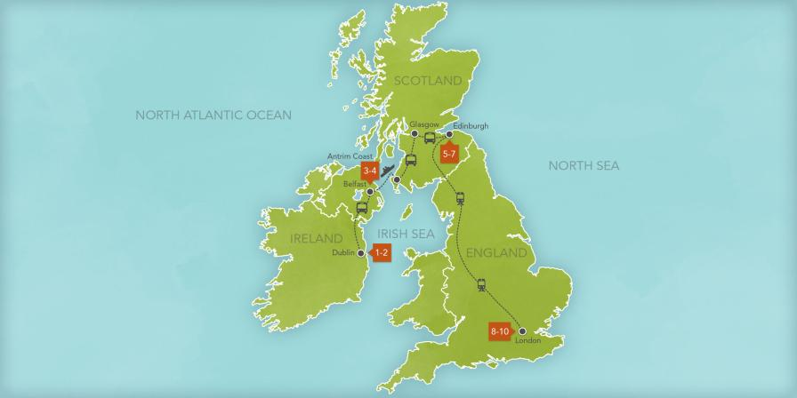

Day 1 – Dublin | Day 6 – Edinburgh
Day 2 – Dublin | Day 7 – Edenburgh
Day 3 – Dublin and Belfast | Day 8 – Edinburgh and London
Day 4 – Antrim Coast  Day 5 – Belfast, Glasgow and Edinburgh | Day 9 – London  Day 10 – London

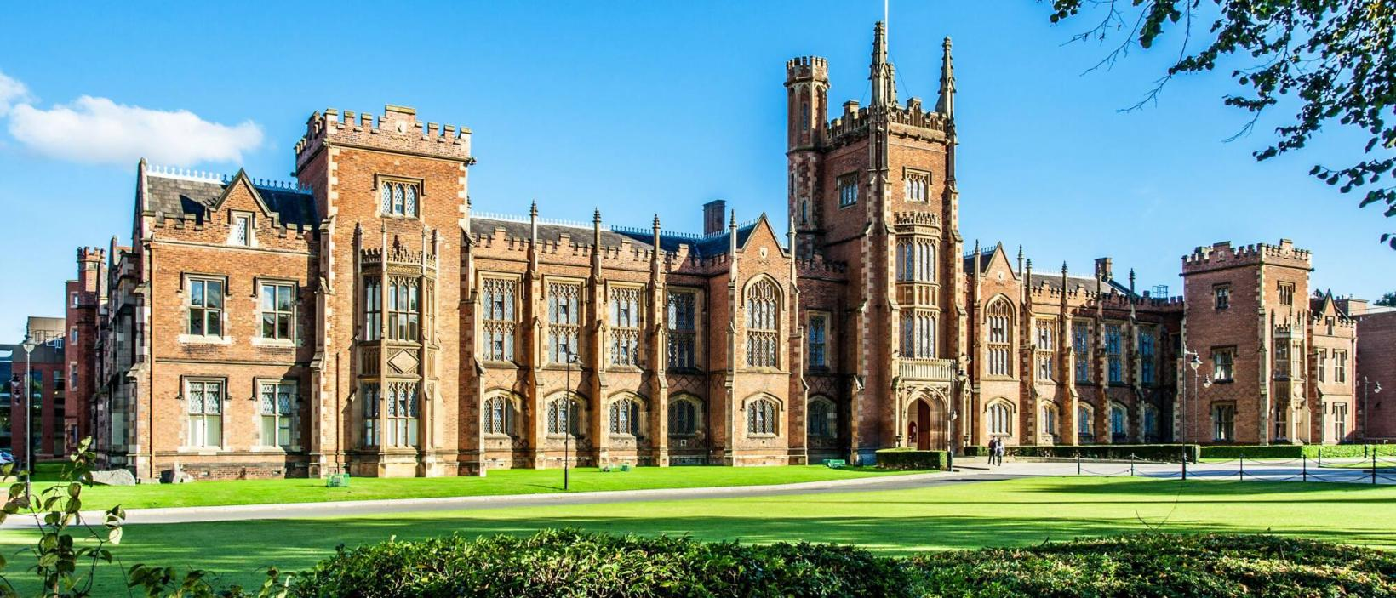

Daily Itinerary

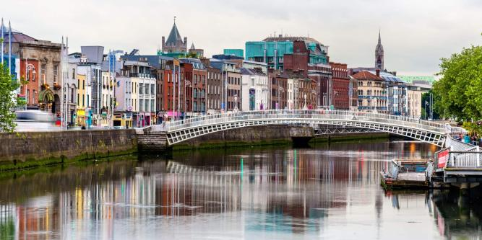
Day 1 – Dublin – Cead Mile Failte

Activities Highlights:
Arrive in Dublin, Check in, Private Welcome Dinner
- Dinner Included
- The College Green Hotel

º Arrive at the Dublin Airport (DUB)
After you pick up your luggage and clear through Customs, an Adventures by Disney representative will meet you in the main terminal and take you to your prearranged transportation to your hotel.

º Check-In at the College Green Hotel in Dublin
Unwind from your travels and explore The College Green Hotel—your home for the next 2 nights—with its traditional setting and contemporary flair that includes a 19th-century façade and all-new interiors. Get acquainted with the many amenities of this idyllic sanctuary in a unique location overlooking Trinity College and Dublin City.

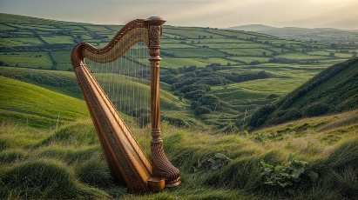
º Private Welcome Dinner
Get to know your fellow Adventurers and the Adventure Guides who will share this amazing trip with you. Then enjoy a private dinner accompanied by the melodic tunes of a Celtic harpist.

Day 2 – Dublin – Life on the Liffy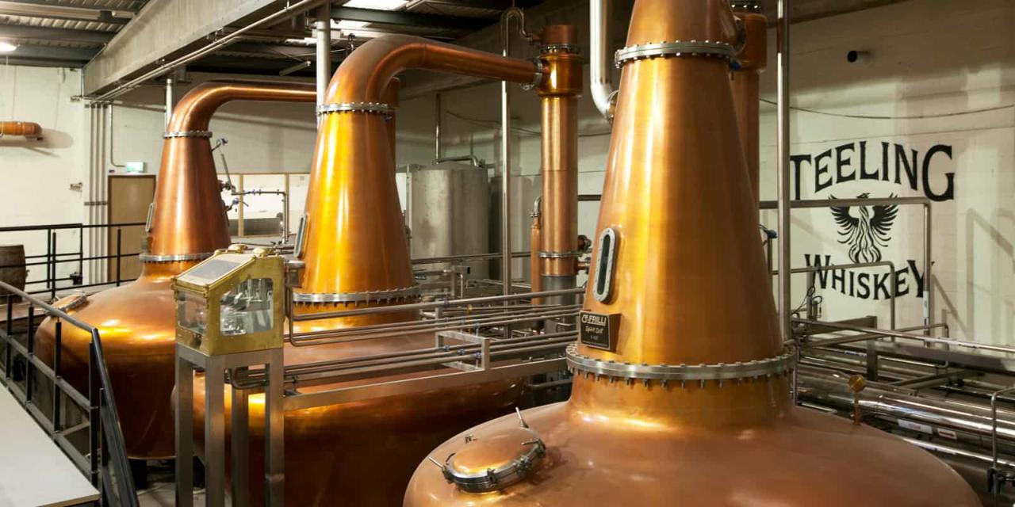

Activities Highlights:
The Irish Emigration Museum, Teeling Whiskey Tour, Private Lunch and Music at an Irish Pub
- Breakfast and Lunch Included
- The College Green Hotel

º Breakfast at the Hotel
Begin your day with a delightful breakfast at the hotel before your adventure begins in Dublin.

º Private Visit to EPIC The Irish Emigration Museum
Enjoy a private visit to the world’s first fully digital museum dedicated to the story of Ireland’s people and how they have influenced and changed the world. Following your visit, you’ll be treated to pastries and tea at a local bakery.

º Teeling Whiskey Distillery Tour & Tasting
Experience the complete whiskey making process with a Teeling Ambassador. For interested adults, a sampling of 3 award-winning Teeling whiskeys paired with delicious Irish chocolate is included. A nonalcoholic beverage will be offered to non-whiskey drinkers.

º Private Lunch and Irish Music at a Local Pub
Take part in a true Irish rite of passage—a visit to a local pub! You’ll enjoy a traditional Irish meal accompanied by local musicians who will regale you with tunes that’ll have you singing along.

º Late Afternoon On Your Own in Dublin
Spend the afternoon exploring historic Dublin. Shop, visit the amazing museums and walk along the cobblestone streets of the Temple Bar neighborhood. Or pop into one of the local pubs for a wee dram o’ whiskey!
º Dinner On Your Own in Dublin
Savor a dinner on your own at one of Dublin's world-class restaurants. Your Adventure Guides will be happy to help you find the ideal place that fits your family’s needs!

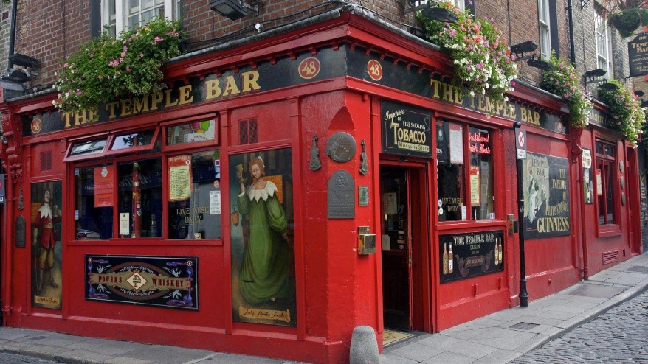

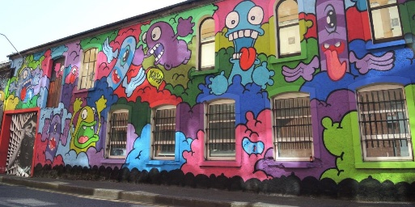
Day 3 – Dublin and Belfast – Ring in the Belfast
Activities Highlights:
Tracey’s Farmhouse Kitchen, Belfast Tour, Titanic Belfast Experience.
- Breakfast, Lunch and Dinner Included
- Grand Central Hotel Belfast

º Breakfast at the Hotel
Begin your day with a delightful breakfast at the hotel before starting your journey to Belfast.

º Tracey’s Farmhouse Kitchen
Experience true Irish authenticity on a visit to this 17th-century farmhouse where Tracey will demonstrate the traditional method of making soda and potato breads on individual griddles. Then, you’ll roll up your sleeves and make your own breads to enjoy.

º Private Lunch at Tracey’s Farmhouse Kitchen
After you’ve worked up an appetite making bread, you’ll dig into a delicious farm-style lunch. And of course, your warm, homemade breads and other sweet treats made by Tracey!

º Belfast Tour
Take a privately guided drive around the wonderful city of Belfast with several brief photo stops. The tour includes historic sights throughout the city, including City Hall, Queens University, Ulster Hall, the Botanical Garden and the wall murals of Falls Road and Shankill Road.
º Titanic Belfast Experience
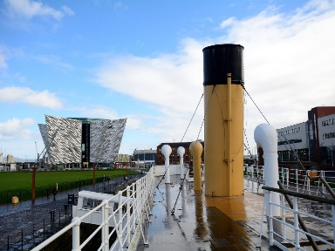
See the world-famous story as you’ve never seen it before—through the eyes of the people that built the “unsinkable” ship. Throughout the immersive self-guided Titanic Experience, you will uncover the sights, sounds, smells and stories of the ship, as well as the people and city that made her. You’ll journey through boomtown Belfast and the shipyard where the liners were built to the launch, fit out and maiden voyage, before discovering more about the sinking, aftermath and Titanic’s final resting place.

º Check-in at Hotel
Upon arrival at your hotel, your Adventures Guides will check you in as you relax and explore the hotel before dinner.

º Dinner at Leisure at Hotel
Dine at leisure with your fellow Adventurers in the comfort of your hotel.

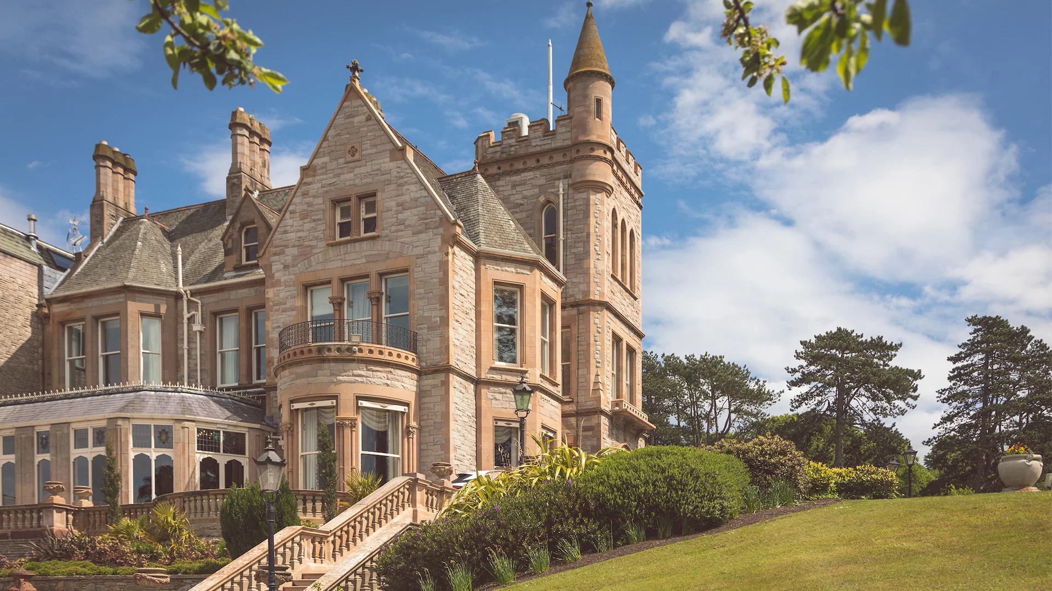

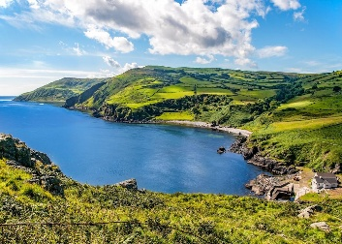
Day 4 – Antrim Coast – Fee-Fi Fo Finn
Activities Highlights:
The Antrim Coast, The Giant’s Causeway, Bushmills Inn
- Breakfast and Lunch Included
- Grand Central Hotel Belfast

º Breakfast at Hotel
Fuel up with a full breakfast at your leisure before heading out for a fun day in Belfast and along the Antrim Coast.

º Journey Along the Antrim Coast
Enjoy a morning driving along the scenic Antrim Coast, designated as an Area of Outstanding Beauty in 1988. Be awed at the stunning views across the sea as you hear stories about the legends and life in the local seaside villages.

º Giant’s Causeway Expedition
Although the “official” explanation is that the 40,000 interlocking basalt columns that make up Giant’s Causeway was formed by volcanic fissure eruptions, don’t rule out that it was formed by Finn McCool, a giant who threw the stones so he could cross the water to fight another giant. Both explanations will be given on your visit, so you can decide which is correct.
º Lunch at Bushmills Inn
Enjoy a delicious lunch at this quaint boutique hotel situated on Northern Ireland’s Causeway Coast. Originally a coaching inn in the 1600s, Bushmills Inn is steeped in Irish history.
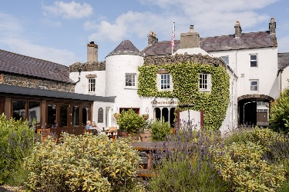
º Dinner On Your Own in Belfast
Upon return from the coast, you’ll be able to relax over a dinner on your own in Belfast or at the hotel. Your Adventure Guides will be happy to recommend some of their favorite restaurants or discover a new favorite of your own.

Day 5 – Belfast, Glasgow and Edinburgh – Piping Good Time
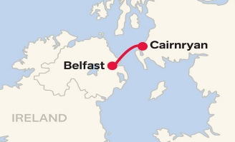
Activities Highlights:
Ferry to Cairnryan, National Piping Center, Pipers Tryst.
- Breakfast, Lunch and Dinner Included
- InterContinental Edinburgh The George
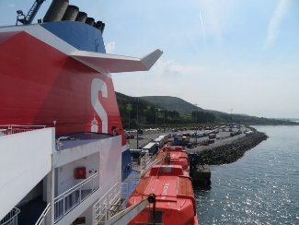
º Ferry to Cairnryan with Breakfast
Start your day bright and early as you ferry from Belfast to Cairnryan, Scotland. While on board, you’ll enjoy breakfast to help fuel you up for the adventure-filled day ahead.

º The National Piping Centre in Glasgow
Take a deep breath and prepare to learn about—and play—the bagpipes. Walk through the informative museum that traces the history of the national instrument of Scotland. Then, put your lungs to the test as you try your hand at making some beautiful music that harkens back centuries of Scottish history.
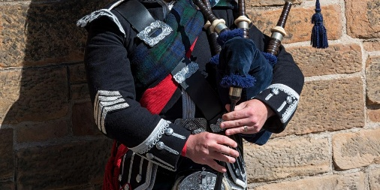
º Private Lunch at Piper’s Tryst
Catch your breath from your bagpipe lesson and dine on a delicious lunch featuring classic Scottish dishes with a modern twist.

º Check-in at Hotel
Following your arrival in Edinburgh, your Adventure Guides will check you in to your hotel and home for the next 3 nights, the InterContinental Edinburgh The George. Enjoy exploring this grand hotel which was established in 1881 and is made up of a collection of fine Georgian townhouses nestled in the city of Edinburgh, a UNESCO World Heritage area.

º Dinner in Edinburgh
Make your way through the exciting bustle of the city streets and enjoy seasonal Scottish cuisine in the heart of Edinburgh.

Day 6 – Edinburgh – Mile of Fun

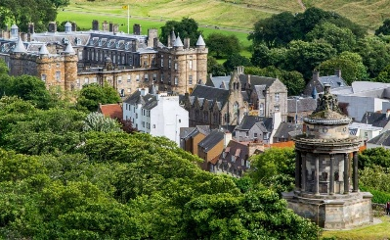
Activities Highlights:
Royal Yacht Britannia, Palace of Holyroodhouse, The Royal Mile, Edinburgh Castle Tour
        - Breakfast Included
        - InterContinental Edinburgh The George

º Breakfast at the Hotel
Start your adventure-filled day with a tasty breakfast.
º Royal Yacht Britannia
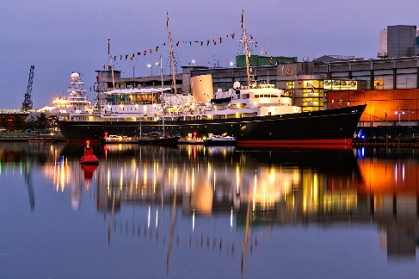
Revel in a Red Carpet Welcome and private visit of the former royal yacht of the British monarch, Queen Elizabeth II. Once on board, you’ll get behind-the-ropes access to areas that include the State Drawing Room—where the Royal Family would entertain dignitaries and heads of state—and the Admiral’s Cabin and Dining Room. You’ll also enjoy a lovely reception with fresh scones and coffee on the Royal Deck Tea Room and discover what life was like on board Her Majesty’s floating Royal Residence.

º The Palace of Holyroodhouse
Explore the royal palace, which is the King of England's official residence in Edinburgh, on a privately guided tour. Over the centuries, great events at Holyroodhouse have shaped the fates of England, Scotland and France.

º The Royal Mile and the Statue of Greyfriars Bobby
En route to Edinburgh Castle, make a stop at the Statue of Greyfriars Bobby, the renowned Skye Terrier. According to legend, this adorable pooch spent 14 years guarding the grave of his owner, until his death. The story of Greyfriars Bobby was so remarkable that Walt Disney Productions turned it into a movie in 1961!
º Lunch On Your Own
Take a break from your walking tour and dine with your friends and family at one of the many restaurant options nearby. Ask your Adventure Guides for recommendations for their favorite spots.
º Edinburgh Castle Tour
Continue your adventure with a privately guided tour of Edinburgh Castle where you’ll take in the resplendent views of the city and explore the castle’s massive fortifications. Revel in the remarkable tales of royal intrigue surrounding the wars for Scottish independence told by your local expert.

º Evening in Edinburgh and Dinner On Your Own
Edinburgh is rich in history and eye-catching architecture. Stroll the Royal Mile, the commercial center of Old Town, and hear the lilting melody of the Scottish brogue in passing conversations. You're sure to fall in love with this charming city as you explore the shops, restaurants and historic buildings of Lawnmarket and High Street. Ask your Adventure Guides to recommend the perfect place to have a memorable dinner.

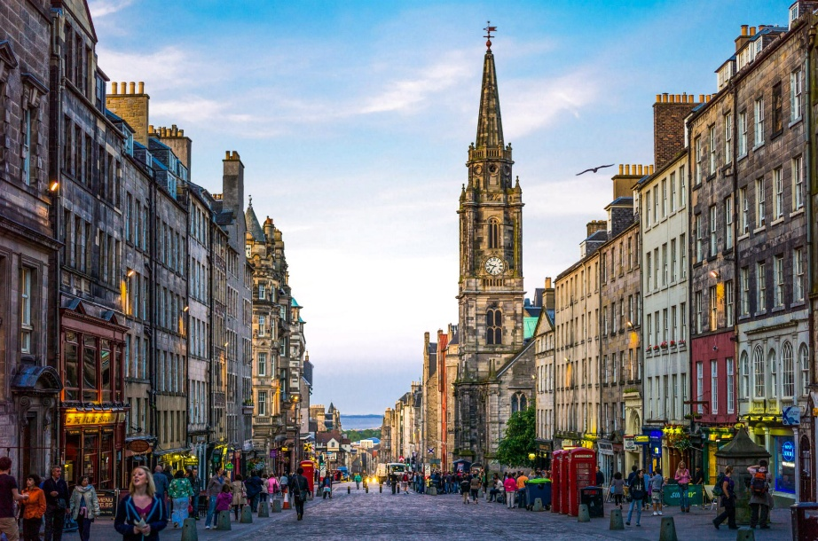
Day 7 – Edinburgh – The Royal Treatment
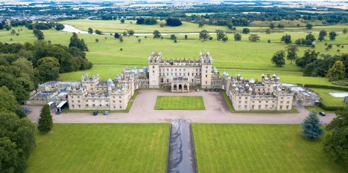
Activities Highlights:
Floors Castle, Shortbread Making!
- Breakfast, Lunch and Dinner Included
- InterContinental Edinburgh The George

º Breakfast at the Hotel
Begin your day with a hearty breakfast at the hotel before heading out on an adventure-filled day.

º Coffee and Tea Reception at Floors Castle
Partake in a delightful reception where you’ll enjoy the exclusive experience of being served tea and cookies by the Private Butler of the Duke and Duchess of Roxburghe, who call Floors Castle their home.

º Floors Castle and Gardens Tour
Experience a day surrounded by all things royal as you embark on a privately guided tour of Floors Castle—the largest inhabited country house in Scotland—and its stunning gardens. View the Duke and Duchess’ amazing art collection as you walk through the grand rooms and hallways that fill the castle. Then, walk the spectacular Walled Garden, site of the formal Millennium Garden and visit Queens’ House, a charming summerhouse named after Queen Victoria, who stayed there in 1867.
º Private Lunch and Exclusive Shortbread-Making Lesson
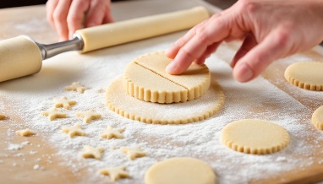
Join your fellow Adventurers at the Castle's Courtyard Café for a private lunch and an exclusive shortbread-making lesson taught by the Private Chef of the Duke and Duchess, where you can try your hand at creating one of these buttery treats!
º Dinner at Leisure at Hotel
Following your return to the hotel, adults will enjoy a relaxing meal in the hotel’s Printing Press Bar & Kitchen, which is the former home of Susan Ferrier, who was the equal of Jane Austen, according to Sir Walter Scott.

º Underground Edinburgh Tour
Discover the true stories of Edinburgh’s dark side as you peek into the city’s ghostly past during this privately guided visit to the underground vaults of Old Town Edinburgh.

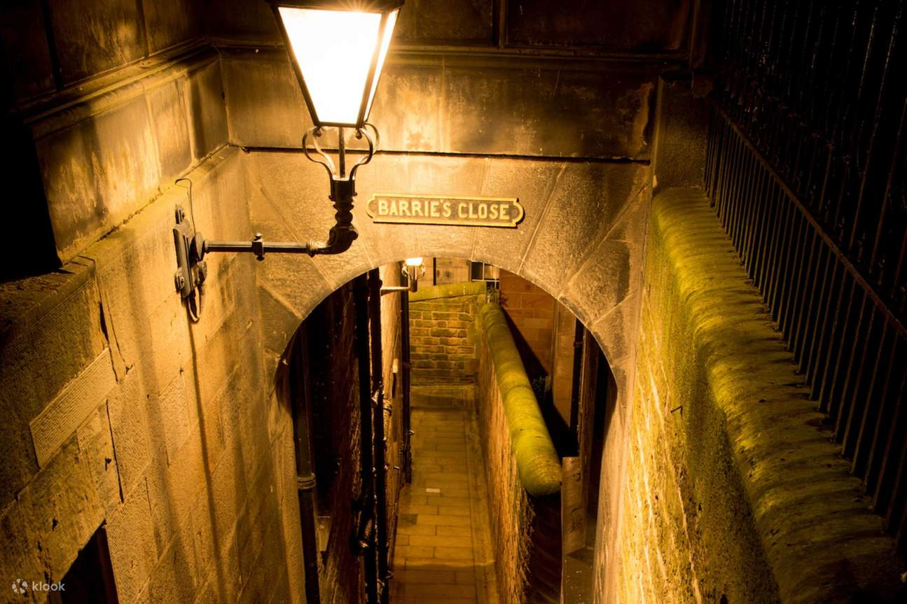
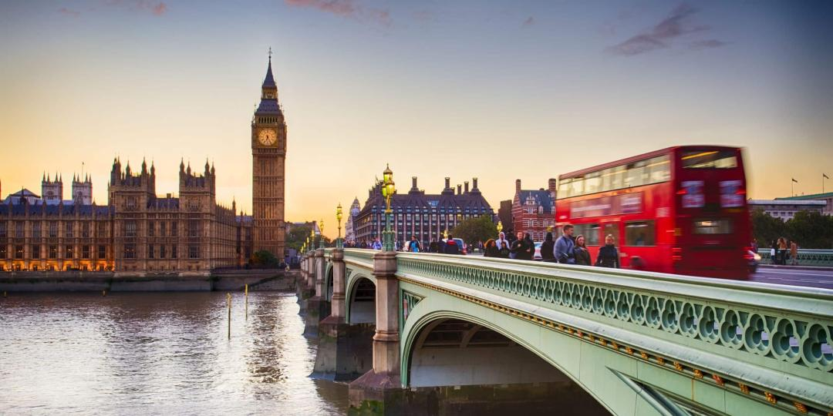
Day 8 – Edinburgh and London – London is Calling
Activities Highlights:
Train to London, Afternoon Tea, Thames Boat Ride
- Breakfast and Lunch Included
- The Waldorf Hilton, London

º Breakfast at the Hotel
Enjoy breakfast at the hotel before heading out to the train station for your journey to London, England.

º Train to London
Sit back and relax on a train ride from Edinburgh to London.

º Afternoon Tea at Hotel
Relax and unwind while sipping a spot of tea accompanied by an assortment of finger sandwiches, homemade scones with clotted cream and preserve and delicate pastries. A selection of fine teas and infusions will be available.

º Thames High-Speed Boat Ride
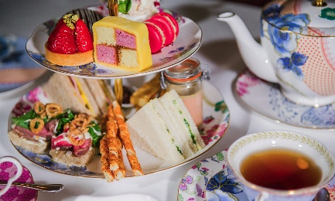
Enjoy a leisurely walk from your hotel before speeding along the world’s most famous waterway, the River Thames, on a private high-speed boat ride. You can check out some of London’s historical sites and iconic scenery as you cruise by.

º Dinner On Your Own in London
Return to the hotel and enjoy dinner and the rest of your evening to explore London on your own. Don’t forget to ask your Adventure Guides for any restaurant recommendations.

Day 9 – London – A Gem of a Day

Activities Highlights:
Private Beefeater Welcome, Viewing of the Crown Jewels, Tower of London, St. Peters Cathedral, Buckingham Palace, Farewell Dinner
- Breakfast, Lunch and Dinner Included
- The Waldorf Hilton, London

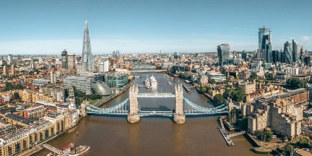
º Breakfast at the Hotel
Enjoy a delightful breakfast at the hotel before heading out for a day full of adventure in London.

º Private Beefeater Welcome
Receive a personal welcome to the Tower of London by one of the famous Beefeater guards. Also referred to as "Yeomen Warders," the Beefeater guards were originally formed in 1485 by Henry VII.

º Private Viewing of the Crown Jewels
Experience this once-in-a-lifetime, private-access viewing of the Royal Crown Jewels at the Tower of London lead by the Tower of London’s Jewel House Warden. A part of the Royal Collection, the Crown Jewels are the most powerful symbol of the British Monarchy.

º Tower of London Privately Guided Tour
Explore this foreboding fortress and learn details about its checkered past! Over the ages, the Tower of London has been guardian of the Crown Jewels, home to all manner of beasts—including lions, bears and other predators—as well as prison to the famous and infamous.

º St Paul’s Cathedral Guided Tour
Known for its iconic dome that has been one of the most recognizable parts of the London skyline for the last 300 years, St Paul’s Cathedral is an integral part of British history. This Anglican cathedral is the seat of the Bishop of London, but fans of the Disney film Mary Poppins may recognize the front steps from the famous “Feed the Birds” song from the original film. You will enjoy a guided tour with commentary from a blue badge guide of this beautiful cathedral that has been the site of countless historical events as well as the jubilee celebrations of Queen Victoria and the wedding of Prince Charles and Lady Diana Spencer.

º Traditional British Lunch at a Local Pub
Tuck into some authentic English fare at a traditional local pub with your fellow Adventurers.
º Buckingham Palace Photo Stop
Stroll from St. James Park to Buckingham Palace where you can snap a pic in front of the historic residence of England’s royal family. When available, witness the royal guards on horseback at Whitehall.

º On Your Own Time in London
Have a jolly time exploring the streets of one of the world’s most amazing cities, that is steeped in centuries of history as well as a contemporary marvel.

º Farewell Dinner at Hotel
Gather together with your fellow Adventurers and new-found friends to share tales of your travels and enjoy a final meal together.

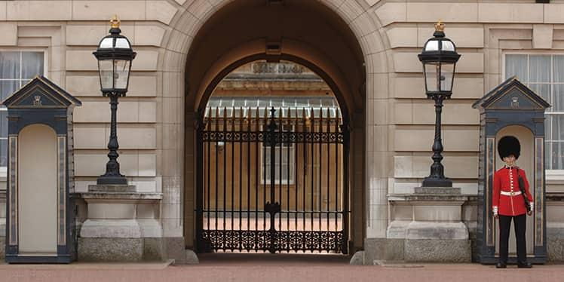
Day 10 – London – Fare Thee Well

Activities Highlights:
Transfer to airport
- Breakfast Included

º Breakfast at the Hotel
Have a final meal in London before heading out to the airport to begin your journey home.

º Transfer London Heathrow Airport (LHR)
Board prearranged private or batched transfers from your hotel to London Heathrow Airport (LHR). Bid the British Isles a fond farewell until you return again!
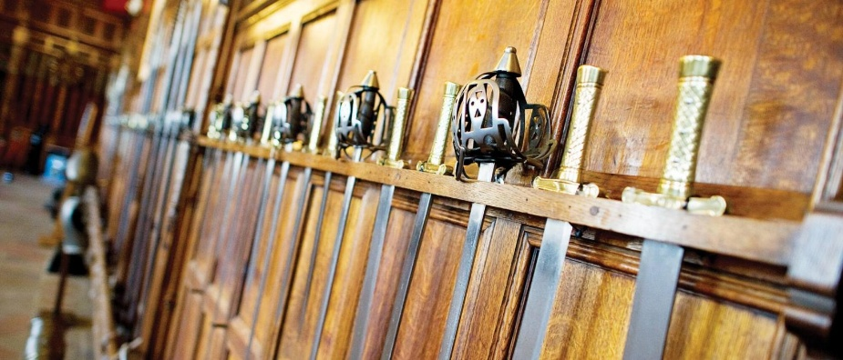

DESTINATION AT A GLANCE
Calling the United States
When calling the U.S. use the example as follows:
00+1+Area Code+7-Digit Phone Number

If using a cell phone, the phone must have international capabilities. Please note that most cell phone service providers require you to have an international calling plan in order for you to place and receive calls from outside of the U.S. Please note some cell phone capabilities may not work while in this destination. Check with your cell phone carrier for details.
Calls from your hotel room will result in charges, which will be billed to your credit card. Follow the directions displayed on the phone for placing
calls. Please note calls can be costly; please check with the hotel for rates.

Electricity
Please be advised that the electrical current in Europe is 220V, 50 Hz. We recommend that you research specific electronics and whether an accessory will be necessary prior to traveling.

Guests with Special Needs
Certain activities may present challenges not suitable for Guests with disabilities or special needs. Adventures by Disney strongly recommends that Guests requiring assistance be accompanied by a companion who is capable of, and totally responsible for, providing assistance. Neither Adventure Guides nor our suppliers may physically lift or assist Guests onto transportation vehicles or otherwise throughout the entire trip. Please contact our Vacationistas at (877) 728-7282 to discuss your specific needs.

Laundry
Select hotels on your adventure offer laundry service for an additional charge. Please note laundry charges can be costly; please check with each individual hotel for rates.

Time
For specific time zone information visit the World Time zone Map at: www.WorldTimeZone.com

Weather
The climate in the British Isles is maritime, moist and temperate. Typically, daytime temperatures range from 42°F (5.5°C) to 66°F (18.8°C), while the evenings rarely get cooler than 40°F (4.4°C). Due to maritime conditions, you should expect some rain during your trip.

fUN fACTS
Ireland

Poet William Drennan was the first to coin the term Emerald Isle in his poem "Erin."

The total size of Ireland is 32,591 square miles (84,400 square kilometers). This makes it almost the size of the state of Maine.

Ireland is famous for its ancient folklore passed down for over 2,000 years from the Druids. This folklore tells tales of fairies and spirits, the most famous of which is the leprechaun. The leprechaun is a shoe-maker fairy that has become rich from the many shoes he has cobbled. Legend says if you catch one while visiting Ireland, he will lead you to his pot of gold!

The Teeling Whiskey Distillery is the first new distillery in Dublin for over 125 years producing up to 500,000 litres of spirit each year.

Scotland
- Scotland has two flags–the Saltire or St Andrew’s cross (white on blue), which is the oldest flag in Europe and the Lion Rampant (yellow and red), which at one time was supposed to only be used by royalty. You’ll now often see both the Saltire and the Lion Rampant flags flying together from major Government buildings and private dwellings.

- The official animal of Scotland is the Unicorn.
- There are three officially recognized languages in Scotland: English, Scots and Scottish Gaelic.

- Loch Ness is the second largest Scottish loch (lake) by surface area and the largest by volume. Because of its great depth of 786 feet (238.0488 meters)–it is deeper than the North Sea–it contains more freshwater than all the lakes in England and Wales combined.
- The modern game of golf originated in Scotland in the 15th Century.

- Scotland has over 6800 miles (10,945 kms) of coastline, from rocky shorelines to secluded island beaches.
- Highland Games include tug-o-war and caber tossing to Highland dance competitions, piping, and field and track events.

- The great Highland bagpipe is considered Scotland’s national instrument, and is one of the most iconic symbols of Scottish culture.
- Tartan, with its colorful threads in traditional patterns, is Scotland’s most famous textile, originating in the Highlands where clans people used local plants, mosses and berries to dye wool before spinning and weaving it into tartan.
London
- London ranks as the third most filmed location in the world. Los Angeles and New York take the top two spots.
- Greater London is home to over 8.6 million people. That represents approximately 14% of the total population in the United Kingdom.
- The London Underground is the subway system that covers the Greater London area. It is estimated that 28 million passengers travel on the subway system each year.

MEALS
Typically, breakfast is served buffet style. Dinners and lunches usually include fish, meat and pasta or rice entrées, vegetables along with salad, soup, cheese, desserts and fruit. Given the nature of group travel, we regret that à la carte menu choices are usually not available. Menu items are subject to change due to the availability and seasonality of foods. In order to offer you and your family a bit of time to enjoy meals amongst yourselves, there are a few meals that are not included in the itinerary. These meals have been planned in towns or cities where you will have plenty of options available. If you have any questions or concerns about dining at any time during your vacation, your Adventure Guides will be happy to assist you.
Special Dietary Requests
Adventures by Disney will make a reasonable effort to accommodate some special dietary requests at no additional charge. Unfortunately, we may not be able to accommodate all special dietary needs requested. Please contact our Vacationistas at (877) 728-7282 in advance of your departure to advise of your requests.

Dining in Ireland
Imagine a law that required you to shelter and feed strangers or face possible punishment. In ancient Ireland, such a custom existed, which may have contributed to the Emerald Isle's well-known tradition of hospitality. These "Brehon Laws" today may lack punitive implications, but the locals say that refusal still may carry the sting of social stigma. Nevertheless, the welcoming spirit pervades in the restaurants and pubs of Ireland's cities and villages. If luck should grant you the kindness of strangers, be prepared for sumptuous feasting, beginning with the traditional Irish breakfast, a meal that can surely sustain you throughout the day. Your morning bounty will generally consist of eggs, rashers (bacon), bangers (sausage), baked fresh tomatoes, fresh mushrooms, white pudding, black pudding, fresh fruit, brown bread or toast, and scones with butter and marmalade.
Meat and potatoes (called "praties") may be the pillars of hearty Irish cuisine, but fresh catches from the sea, such as salmon, trout and shellfish are popular alternatives at the dining table. Sharing a drink offers further social engagement, whether it is a steaming brew of tea, chilled pint of beer or whiskey shot. There are a number of breweries located throughout Ireland spouting award-winning ales, stouts, ciders and microbrews. Arguably, the most renowned beer is Guinness, brewed at St. James Gate, Dublin. Whiskey in Ireland dates back to the 12th Century when traveling monks brought over distilling techniques from continental Europe.
Below are some items you may encounter on menus at Irish restaurants and pubs. You may stumble over some of the ingredients, but you may recognize a few of them as something familiar to your palette back home.
- Colcannon: Cabbage, kale, or other greens mixed with potatoes, boiled and mashed together.
- Irish Brown Bread: Special whole-meal wheat flour gives this baked staple a nutty flavor and slightly coarse texture.
- Irish Coffee: Coffee, cream and a bit of Irish whiskey.
- Irish Stew: A stew made of mutton, lamb, or beef with potatoes, onions and other vegetables. Also called Mulligan stew.
- Shephard's Pie: A baked dish of ground or diced meat with a crust of mashed potatoes.
- Soda Bread: An Irish quick bread leavened with baking soda, normally made with buttermilk.
Cultrual Dining Information
In Ireland, the gratuity is typically included in your bill.
Dining in Scotland
From the traditional fish and chips, haggis and tatties to the more current fusion gastronomy that blends the best of Scottish ingredients with other culinary traditions, Scottish dining can be an adventure of its own. With an unspoiled environment and a climate without extremes, Scotland enjoys ideal conditions to produce high-quality foods for its culinary specialties. Whether you choose to enjoy an Aberdeen rowie, a savory Scottish bread roll noted for its flaky texture and buttery taste or oak-smoked organic Scottish salmon with Shetland Mussels, your options are as varied as the Scottish countryside.
For years oats in all forms have been a staple food in the Scottish diet. Porridge and oatcakes are still prominent, but today’s Scottish fare is known for local delicacies such as Arbroath smokies, Lochfyne kippers, Forfar Bridies, Selkirk bannocks, Orkney, Islay and Galloway cheeses, just to name a few.

Whisky and beer are two of the main ingredients in experiencing great Scottish craic (fun)! Acknowledged as Scotland’s national drink, whisky–in the Gaelic, uisge beatha (pronounced oosh-ga beh-huh), means water of life–has been produced in Scotland for longer than anyone can remember. From succulent Angus beef, mutton and lamb to locally harvested seafood, enjoy the Scottish offering of creative dishes and be sure to share the varied tastes with each other.
Below are some items you may encounter on menus at Scottish restaurants and pubs.

Traditional Dishes
- Haggis, Neeps & Tatties: The quintessential dish—savory pudding made of sheep's offal, oatmeal, and spices, paired with mashed turnips and potatoes.
- Cullen Skink: A thick, creamy soup made with smoked haddock, potatoes, and onions.
- Scottish Salmon: Famous for its high quality, often served smoked, or grilled.
- Balmoral Chicken: Chicken breast stuffed with haggis and wrapped in bacon.
- Scotch Pie: A small, double-crust meat pie typically filled with minced mutton.
- Black Pudding & Lorne Sausage: Common staples of a traditional Scottish breakfast.
Comfort Food & Seafood
- Arbroath Smokies: Small haddock smoked over hardwood.
- Mince and Tatties: A simple, popular comfort dish of minced beef and mashed potatoes.
- Clootie Dumpling: A traditional spiced fruit pudding.
- Fresh Seafood: High-quality langoustines, scallops, and crab are widely available.
Snacks & Drinks
- Shortbread: Buttery biscuit.
- Irn-Bru: A bright orange, iconic carbonated soft drink.
- Aberdeen Butteries (Rowies): A salty, flaky pastry.
- Tunnock's Teacakes: A famous biscuit-based chocolate-covered

Dining in London
London is one of the most influential cities in the culinary world. The heart of English cuisine is the pub, where traditional fare, such as meat pies, fish and chips, mashed potatoes and cheeses, are served up with cold stout or ale on tap.

During your adventure, you will have the opportunity to savor a variety of distinct international flavors. Here are some common English dishes you may want to try:
- Bangers and Mash: Sausages accompanied by mashed potatoes.
- English Breakfast: Eggs, bacon, sausages, fried bread, mushrooms, baked beans.
- Fish and Chips: Deep-fried fish fillets and french fries.
- Shepherd’s Pie: Minced beef covered with mashed potatoes. A similar dish with fish instead of meat is called Fisherman’s Pie.
- Yorkshire Pudding: Popular side dish served with roast beef. Batter is often poured into the same pan as the meat in order to absorb the fat and juices.

COMMON WORDS & PHRASES
Ireland
AN TSIONNA (UHN SH-E-NN-OH-AH) - Shannon
BAILE ÁTHA CLIATH (B-UH-EH AH-HUH KEL-EE-AH-HEH) - Dublin
CÉAD MILE FÁILTE (KEE-AT MEAL-A FAL-CHE) - A Hundred Thousand Welcomes
CILL AIRNE (KEL-AH-E-NEH) - Killarney
CONAS ATÁ TÚ (KAHN-UHSH UHCH-AH) - How are you?
CRAIC (CRAK) - Fun and entertainment
FIR (FERR) - Men
GO RAIBH MAITH AGAT (GAH RUH-EH-VEE MUH-EH UHG-UHCH) - Thank you
LE DO THOIL (LEH JAH HA-EL) - Please
MNÁ (MNAH) - Women
ÓSTÁN (OH-SHCH-AHN) - Hotel
SIÁN (SHLAHN UGUT) - Goodbye
SLÁINTE! (SHLAHN TEH) - Cheers!

Scotland
FÀILTE (FAY-AY) - Welcome
HALÒ (HALL-OW) - Hello
SLÁINTE (SHLAHN TEH) - Cheers
NAE PROBLEM (NAY-PROBLEM) - No problem
AN TSIONNA (UHN SH-E-NN-OH-AH) - Shannon
BAILE ÁTHA CLIATH (B-UH-EH AH-HUH KEL-EE-AH-HEH) - Dublin
CÉAD MILE FÁILTE (KEE-AT MEAL-A FAL-CHE) - A Hundred Thousand Welcomes
CILL AIRNE (KEL-AH-E-NEH) - Killarney
CONAS ATÁ TÚ (KAHN-UHSH UHCH-AH) - How are you?
CRAIC (CRAK) - Fun and entertainment
FIR (FERR) - Men
GO RAIBH MAITH AGAT (GAH RUH-EH-VEE MUH-EH UHG-UHCH) - Thank you
LE DO THOIL (LEH JAH HA-EL) - Please
MNÁ (MNAH) - Women
ÓSTÁN (OH-SHCH-AHN) - Hotel
SLÁN (SHLAHN UGUT) - Goodbye
ALBA GU BRÀTH - Scotland Forever
TURAS MATH DHUT - Have a good trip!

London
CASHPOINT MACHINE: ATM
CHIPS: French Fries
CRISPS: Chips
LOO OR TOILET: Restroom
MATE: Friend
TELEPHONE BOX: Phone Booth
TRAINERS: Sneakers
TUBE OR UNDERGROUND: Subway

Gratuities, Money and Shopping
Gratuities for your Adventure Guides are not included. For your convenience, gratuity envelopes were mailed to you with your Adventures by Disney Gift Collection. Please bring the envelopes with you to destination. Please see the full Adventurers Guide on suggested tips for your guides.

Currency

At this time the unit of currency in Ireland is the Euro (EUR). The unit of currency in Northern Ireland, ﻿Scotland and London is the British Pound Sterling (GBP). U.S. dollars are not accepted at hotels, shops or restaurants, but ATMs are readily available in most towns and cities along your adventure to obtain cash in local currency. The best rate of exchange is received from ATMs, or by paying for goods and services with a major credit card. Most hotels, restaurants and shops in Scotland accept major credit cards or single-use debit cards in addition to travelers’ checks. While you may cash travelers’ checks at hotels, the rate of exchange is generally not very favorable. Small cafés, shops and newspaper stands generally accept only cash (in local currency). We are often asked if cash in U.S. dollars is necessary. The only use for cash in U.S. dollars may be for your Adventure Guides’ gratuities.

ATMs

ATMs are readily available in most towns and cities along your adventure. Please keep the following information in mind when using an ATM:

Some financial institutions charge an international withdrawal fee. Contact your financial institution for more information.

ATMs may have a daily withdrawal limit.

The U.S. Department of State notes that counterfeit currency is a growing problem and recommends that Guests avoid random money exchange locations and only use ATM machines connected directly to a bank.

The Department of State reports that incidents of credit card fraud are also on the rise and advise travelers to keep their credit cards within sight when making transactions.

Adventure Guides are always happy to assist in finding the nearest bank for our Guests.

Shopping
If you are buying large items, inquire if the store offers shipping to the United States. ﻿It is recommended that you carry a small amount of cash in local currency with you.

Popular Souvenirs

Souvenir hunting abounds in all visiting destinations. Here are suggestions for popular items to give family and friends - unique reminders of your British Isles adventure.

Ireland:
- Handknit items
- Pottery
- Jewelry
- Linen
- Crystal

Note: Any goods purchased while in Ireland may qualify for a Value Added Tax (VAT) refund. Be sure to ask the shopkeepers when making purchases.

Scotland:
- Food and Drink – Scotch whisky (should be purchased at the duty-free shop at the airport).
- Clothing – Cashmere scarves, gloves, tweed hats, tartan pattern ties and kilts.
- Silver Quaich – The Quaich is a two-handled communal drinking vessel.
- Spurtle – Unique to Scotland, the spurtle is a wooden cooking tool used to stir porridge.
- Heather Gems – Heather stones are jewelry and giftware made from natural heather stems.
- Harris Tweed Tea Cosy – Tea cosies made with the world-famous Harris Tweed come in various designs and colors.

London
- Clothing: Silk scarves and dressing gowns.
- Food items: Teas, chocolates, coffees and cheeses.
- Royal souvenirs: China, teddy bears in guard uniforms, figurines, postcards and books.
- Traditional toiletries: Handmade colognes, shaving preparations and aromatherapy oils.

Adventures by Disney Reservations Center
1+(877) 728-7282

24-Hour Emergency Contact
Within the U.S. 877-728-7282
Outside the U.S. +1-407-828-7117

